

COURSE PROJECT REPORT

Subject: PRN222

– Quy Nhon, March 2026 –

Table of Contents
Record of Changes 3
I. Overview 4
I.1 Project Information 4
I.2 Project Team 4
II. Requirement Specification 4
II.1 Problem description 4
II.2 Major Features 4
II.3 Context Diagram 4
II.4 Nonfunction Requirements 5
II.5 Functional requirements 5
II.5.1 Actors 5
II.5.2 Use Cases 5
II.5.2 .1 Diagram(s) 5
II.5.2.2 Use case descriptions 6
II.5.3 Activity diagram 8
III. Analysis models. 9
III.1 Interaction diagrams 9
III.2 State diagram 10
IV. Design specification 11
IV.1 Integrated Communication Diagrams 11
IV.2 System High-Level Design 11
IV.3 Component and Package Diagram 11
IV.4 Class diagram 12
IV.5 Database Design 12
V. Implementation 13
V.1 Map architecture to the structure of the project 13
V.2 Map Class Diagram and Interaction Diagram to Code 13
V. Applying Alternative Architecture Patterns 13
V.1 Applying the service-oriented architecture 13
V.2 Applying Service Discovery Pattern in the service-oriented architecture 13

Group 2 - SE18D.NET
Full Name | Student Code | Role | Email
Nguyễn Quang Duy |  | Lecture | Duynq27@fe.edu.vn
Đinh Ngọc Thiện | QE180208 | Member | Thiendnqe180208@fpt.edu.vn
Thái Hoàng Giang | QE180129 | Member | Giangthqe180129@fpt.edu.vn
Trần Minh Quân | QE180065 | Member | Quantmqe180065@fpt.edu.vn

Record of Changes
Date | A*  M, D | In charge | Change Description
18/09/2025 | A
*A - Added M - Modified D - Deleted

I. Overview

I.1 Project Information
- Project name: Library Management System
- Project code: SP26-LMS
- Group name: PRN222-G2
- Software type: Web Application (ASP.NET Core MVC)

II. Requirement Specification

II.1 Problem description

In practice, traditional library management often faces several challenges. Manual book management is prone to errors, making it difficult to maintain accuracy. Tracking borrowing and returning history is also complicated, while the condition of books is not effectively monitored. Additionally, searching for books can be time-consuming, and generating statistical reports is not efficient.
Therefore, a Library Management System (LMS) is developed to address these issues. It helps automate library operations, improves overall efficiency, and provides a better user experience for both librarians and readers.

II.2 Major Features
FE-01: Book Management (CRUD Book- Create, Read, Update, Delete)
FE-02: Category Management
FE-03: Book Copy Management
FE-04: User/Reader Management

FE-05: Borrowing Management
FE-06: Return Management
FE-07: Loan Management
FE-08: ReaderManagement
FE-09: Account Management
FE-09: Statistics and Reporting
FE-10: Authentication & Authorization

II.3 Context Diagram
- The Library Management System (LMS) interacts with several key components, including the Administrator, Librarian, Member, and the database (SQL Server). Each role has specific responsibilities within the system, allowing for efficient management and operation of library activities.
- In terms of data flow, users such as administrators, librarians, or members send requests to the system to perform actions like managing books, borrowing, or returning. The system then processes these requests by interacting with the database, where all information is stored and managed. After processing, the system returns the appropriate data or response back to the user, ensuring smooth and efficient communication between all components.

II.4 Nonfunctional requirements

# | Feature | System Function | Description
1 | Performance | Fast Response | Process requests in under 2 seconds
2 | Security | Authentication | Login and authorization
3 | Scalability | Expandable | Easy to scale and extend
4 | Maintainability | Modular | Well-structured layered code
5 | Usability | User-friendly UI | Easy to use

II.5 Functional requirements

II.5.1 Actors

# | Actor | Description
1 | Administrator | Responsible for managing the entire system, including configuring system settings, managing user accounts and roles, and ensuring overall system security and performance. The administrator has full access to all features and can monitor and control all activities within the LMS.
2 | Librarian | Acts as the library staff who handle daily operations such as managing books, categories, and book copies. They are also responsible for processing borrowing and returning transactions, assisting members, and maintaining the accuracy of library data.
3 | Member | Refers to the users who borrow books from the library. Members can search for books, view availability, borrow and return books, and track their own borrowing history through the system.

II.5.2 Use Cases

* Actor: Administrator

- Manage Librarian Accounts: Create, update, or delete librarian credentials.

- Manage Member Roles: Define and assign access permissions to different user types.

- Monitor System Activity: View real-time system status and security logs.

- Generate Performance Reports: View high-level reports on system usage and performance.

* Actor: Librarian

Manage Book Catalog:

- Add new books.

- Update book details.

- Delete/Remove books.

- Organize/Categorize books.

Process Borrowing: Record books being checked out by members (manage due dates).

Process Returns: Check books back into the system and update availability.

Manage Member Information: Create or update member profiles and assist with account issues.

Generate Operational Reports: Create reports on borrow frequency, popular books, and overdue items.

Actor: Member

- Search Books: Find books by title, author, category, or keyword.

- Browse Catalog: View the list of available books.

- Borrow Book: Initiate a borrowing transaction (subject to library rules).

- Return Book: Initiate a return transaction.

- View Borrowing History: See a log of previously borrowed items.

- View Loan Status: Check current due dates and status of active loans.

II.5.2 .1 Diagram(s)

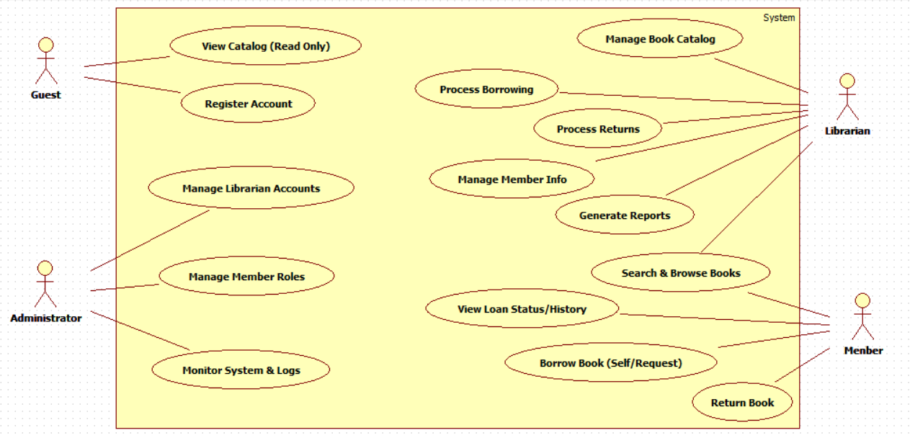

II.5.2.2 Use case descriptions

ID | Use Case | Actors | Use Case Description
01 | View Loan Status/History | Member | The Member logs in to view their current active loans, due dates, calculated fines, and historical borrowing records.
02 | Borrow Book | Member | The Member initiates a borrowing request, either via a self-service kiosk or by bringing the book to the desk for the Librarian to process.
03 | Return Book | Member | The Member physically returns the book to the library drop-off zone or help desk to close their loan transaction.
04 | Search & Browse Books | Member, Librarian | Users search the library database using keywords (Title, Author, Genre) to find book locations and check real-time availability.
05 | Manage Book Catalog | Librarian | The Librarian adds new book records (ISBN, Title, Author), updates existing metadata, or marks books as lost/damaged/removed.
06 | Process Borrowing | Librarian | The Librarian validates a Member's account status (checking for fines/limits) and scans the book to officially check it out in the system.
07 | Process Returns | Librarian | The Librarian scans returned items, checks for damage, calculates any late fees, and updates the book status back to "Available."
08 | Manage Member Info | Librarian | The Librarian updates member contact details, validates registration applications, and manually clears fines if payment is made.
09 | Manage Librarian Accounts | Administrator | The Administrator creates, updates, or deletes accounts for library staff. This includes resetting passwords and managing access permissions.
10 | Manage Member Roles | Administrator | The Administrator defines and assigns roles (e.g., Student, Faculty, Staff) which dictate borrowing limits and loan durations.
11 | Monitor System & Logs | Administrator | The Administrator views system logs to track user activities, detect security breaches, and monitor system health/errors.

1 <<Customer>>

Functional Description Template
UC ID and Name: | UC-01: Borrow Book
Created By: | Dinh Ngoc Thien | Date Created: | 21/01/2026
Primary Actor: | Member | Secondary Actors:
Trigger:
Description: | This use case describes the process where a registered Member borrows physical items from the library. The system validates the Member’s status and the availability of the items, updates the inventory, and assigns a due date for the return.
Preconditions: | The Member has an active account (not expired or suspended).  The Book exists in the catalog and its status is "Available".  The Member has verified their identity (e.g., has a library card or login credentials).
Postconditions: | Success: The system records the loan, the book status is updated to "Borrowed," the due date is set, and a receipt (physical or digital) is generated.  Failure: The book remains "Available" (or is held), and no loan is recorded against the Member's account.
Normal Flow: | Member presents their library card or logs into the self-service kiosk.  System validates the Member’s account (checks for blocks, expired membership).  Member (or Librarian) scans the barcode of the book(s).  System retrieves book details and verifies it can be borrowed (not reference-only, not reserved by another).  System checks business rules (borrowing limits, existing fines).  System registers the loan, calculating the due date based on Member Role.  System deactivates the security tag on the book.  System confirms the transaction and issues a receipt/email to the Member.
Alternative Flows: | Librarian Assisted (Desk Service)  - In Step 1, the Member hands the card to the Librarian.  - In Step 3, the Librarian performs the scanning.  - The Librarian manually hands over the books and receipt.  Multiple Items  - Steps 3–5 are repeated for each book. If one book fails validation, the others can still be processed.
Exceptions: | Member has outstanding fines  - In Step 2 or 5, the System detects fines exceeding the allowable threshold.  - System displays an error: "Outstanding fines. Please resolve with Librarian."  - Use Case terminates or switches to "Pay Fines" flow.  Maximum borrowing limit reached  - In Step 5, System detects the Member has reached their maximum loan quota.  - System prevents adding the new item.  Book is Reserved  - In Step 4, System detects the book is on "Hold" for another user.  - System denies the loan request.
Priority: | High (Medium, Low), Must Have (Should Have, Could Have),..
Frequency of Use: | Very High (Daily, multiple times per hour)
Business Rules: | Max Items: Students can borrow up to 5 books; Faculty up to 10.  Loan Duration: Standard loan is 14 days; Reference materials cannot be borrowed.  Fines: Borrowing is blocked if fines exceed 10.000.VND
Other Information:
Assumptions:

II.5.3 Activity diagram

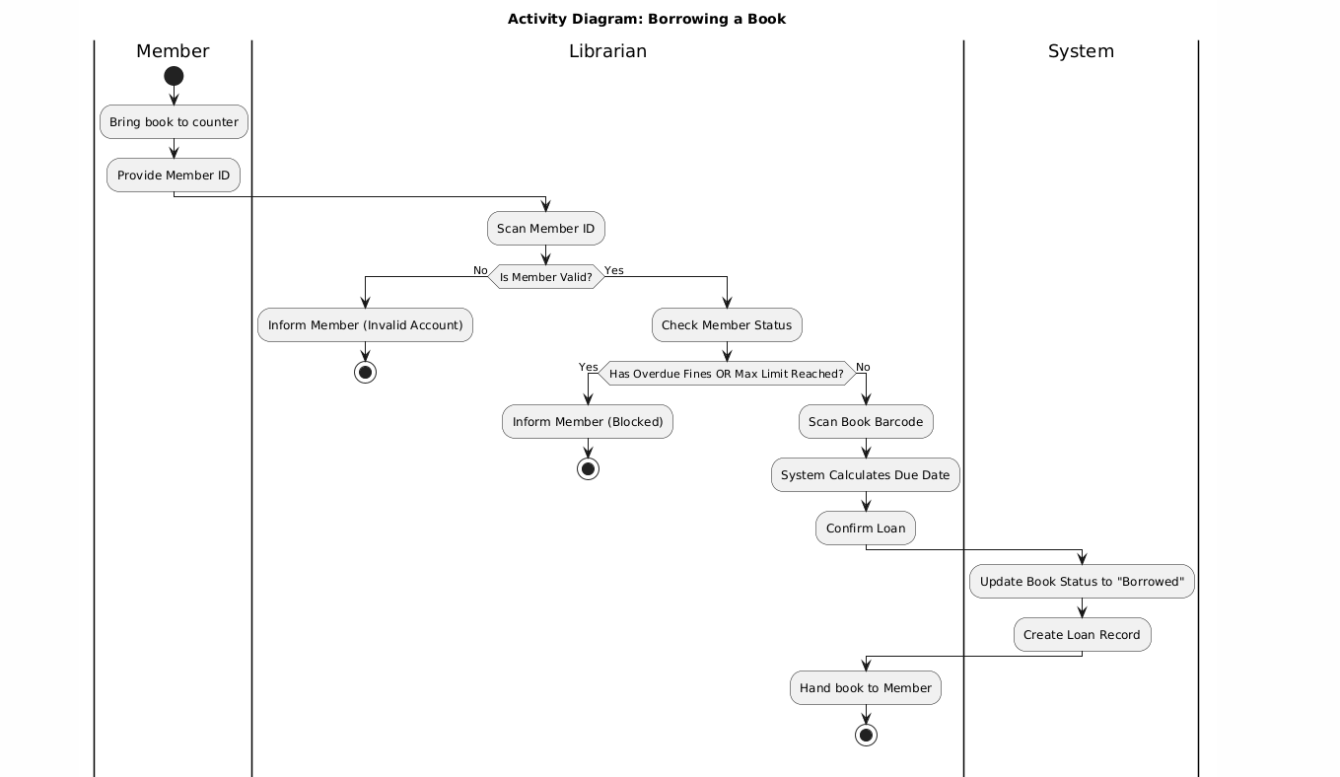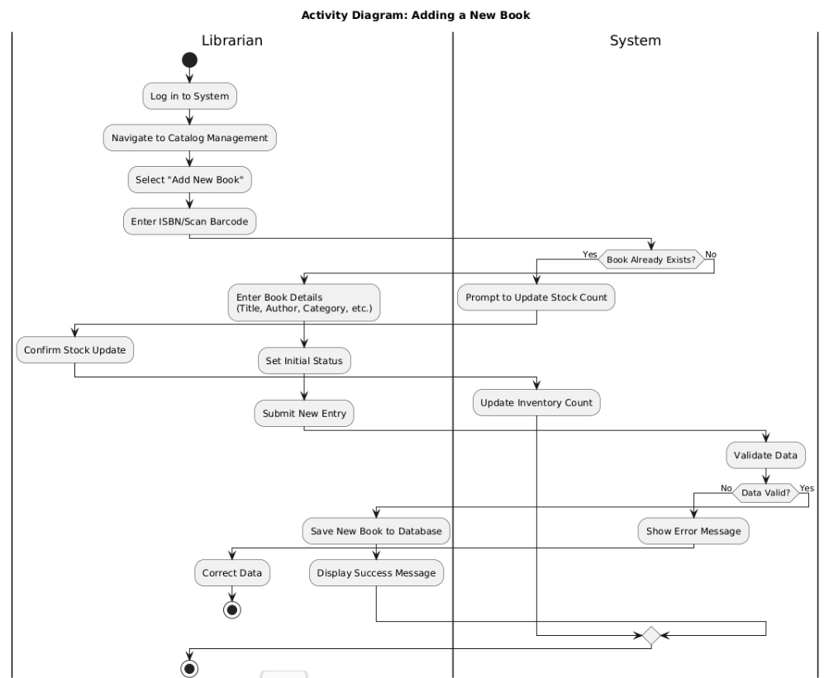

II.6 Entity Relationship Diagram

III. Analysis models.

III.1 Interaction diagrams

III.1.1.Sequence Diagram
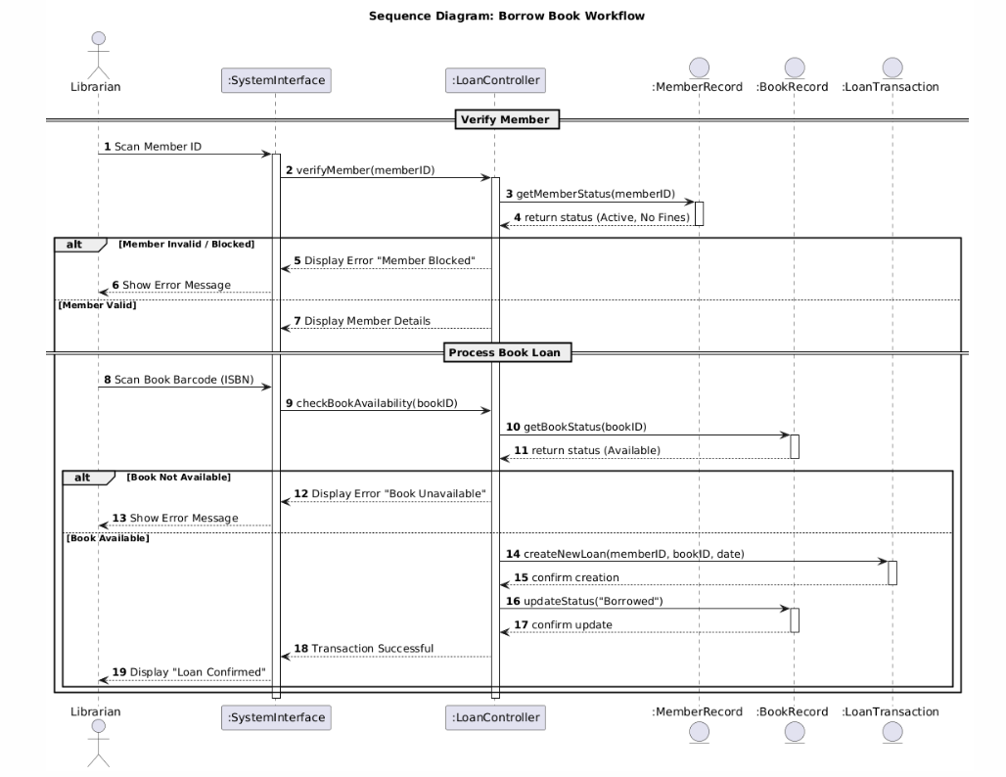

III.1.2. Communication Diagram

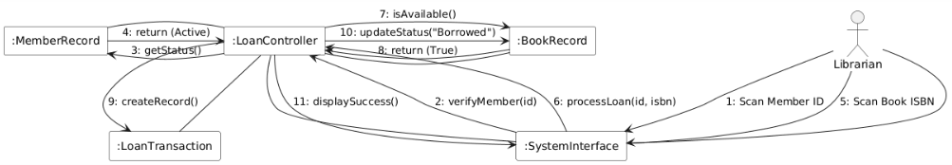

IV. Design specification

IV.1 System High-Level Design

- The Library Management System adopts a Layered Architecture pattern. This architectural style organizes the system into distinct logical layers, where each layer has a clearly defined responsibility and communicates only with adjacent layers.

- The Layered Architecture was selected based on the nature of the system requirements. The system includes multiple functional modules such as user management, book catalog management, loan processing, and reporting. By separating presentation logic, business rules, and data access operations, the architecture improves maintainability, scalability, and modularity.

The system consists of four main layers:

- Presentation Layer

- Application Layer

- Business Layer

- Data Access Layer

-> This structure ensures separation of concerns and reduces system complexity.

IV.2 Component and Deployment Diagram

IV.2.1 Component Diagram

- The Component Diagram presents the internal structure of the Library Management System based on the Layered Architecture. The system is divided into four layers: Presentation, Application, Business, and Data Access.

- The Presentation Layer handles user interaction through the Web UI. The Application Layer contains controllers that process requests. The Business Layer implements core logic such as borrowing validation, fine calculation, and role management. The Data Access Layer manages database operations through repositories connected to the LMS Database.

- This layered design ensures clear separation of responsibilities and improves maintainability.

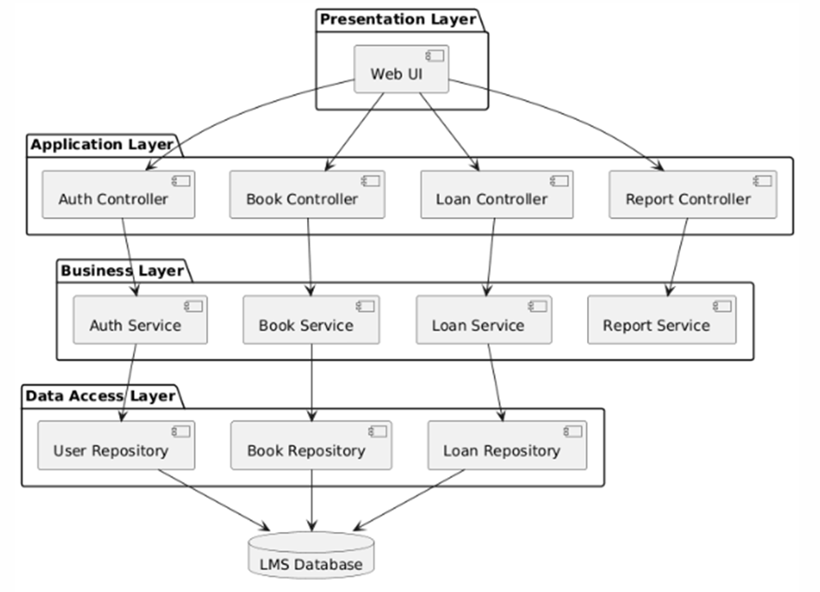

IV.3.1 . Deployment Diagram

- The Deployment Diagram illustrates the physical deployment of the system using a three-tier model. Users access the system via a Web Browser on a client device. The application is hosted on an Application Server, where all business logic is executed. A separate Database Server stores system data in the LMS Database.

- This deployment structure supports centralized processing and allows multiple users to access the system efficiently.

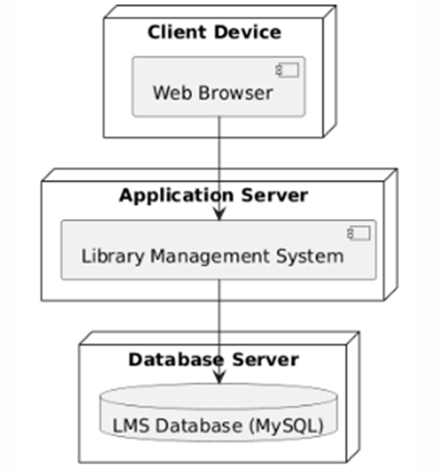

IV.4 Class diagram

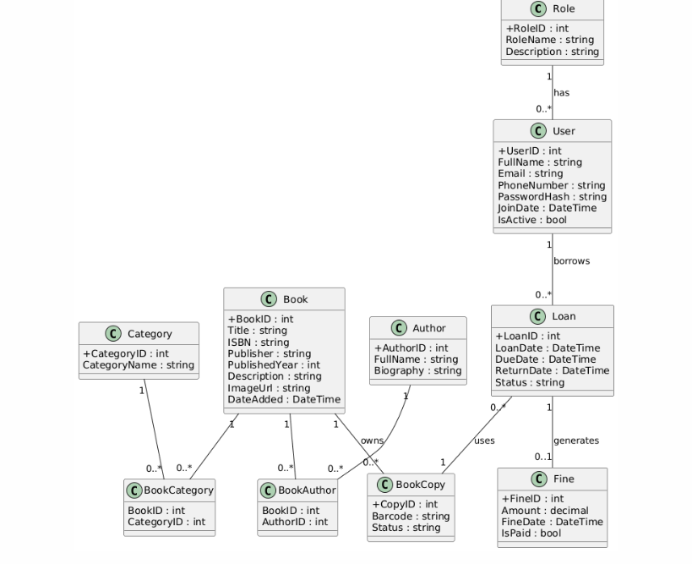

IV.5 Database Design
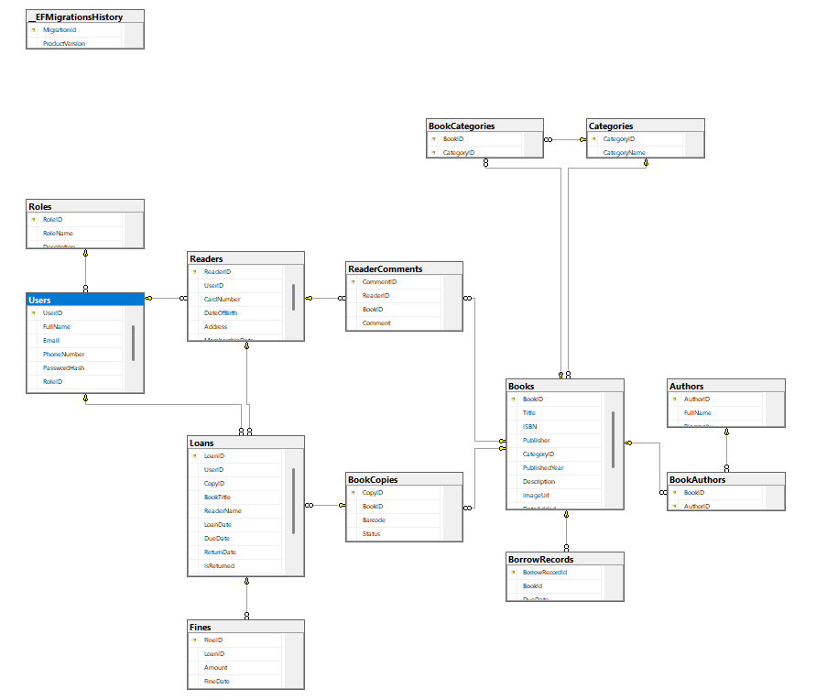

V. Implementation

V.1 Map architecture to the structure of the project
[Provide:
- Overview of the Chosen Architecture
The Library Management System is developed using a combination of Layered Architecture (N-Tier) and the Model–View–Controller (MVC) pattern.
- MVC is applied in the presentation layer to handle user interactions.
- Layered Architecture ensures a clear separation between different system concerns such as presentation, business logic, and data access.
The system is divided into the following layers:
- Presentation Layer (MVC)
- Service Layer (Business Logic)
- Repository/Data Access Layer
- Domain/Entities Layer
- Database Layer (SQL Server with Entity Framework Core)

2. Why this Architecture was Selected

This architecture was chosen because it satisfies important non-functional requirements:

- Maintainability:
Each layer is independent, making it easier to fix bugs and update features without affecting the entire system.
- Scalability:
New features or modules can be added with minimal changes to existing components.
- Reusability:
Services and repositories can be reused across multiple controllers.
- Separation of Concerns:
Each layer has a clearly defined responsibility, improving code organization.
3. Mapping to Project Structure

Based on the provided project structure, the architecture is mapped as follows:

🔹 3.1 Domain Layer (Entities / Business Objects)
BusinessObjects/Entities

This folder contains entity classes representing the system data:
- Book.cs
- Author.cs
- BookCopy.cs

- BookStatisticsViewModel.cs

- ReaderComment.cs

- TopBookViewModel.cs

- Category.cs
- Reader.cs
- Loan.cs
- BorrowRecord.cs
- Fine.cs
- User.cs
- Role.cs
Responsibility:
- Represent database tables
- Serve as core domain models
🔹 3.2 Data Access Layer (DAO + DbContext)
DataAccessObjects

- LibraryManagementDbContext.cs
- BookDAO.cs
- ReaderDAO.cs
- LoanDAO.cs
- CategoryDAO.cs
- AccountDAO.cs
- BookCopyDAO

Migrations : Code first

Responsibility:

- Direct interaction with the database
- Uses Entity Framework Core
- Performs CRUD operations
🔹 3.3 Repository Layer
Repositories
- GenericRepository.cs
- BookRepository.cs
- ReaderRepository.cs
- LoanRepository.cs
- UserRepository.cs

- BookCopyRepository

- CategoryRepository

Interfaces:

- IBookRepository.cs
- IReaderRepository.cs
- IGenericRepository.cs
- ILoanRepository.cs

- IBookCopyRepository

- IReaderRepository

- IUserRepository
Responsibility:
- Abstract data access logic
- Decouple DAO from Service layer
- Improve testability (via interfaces)
🔹 3.4 Service Layer (Business Logic)

Services
- BookService.cs
- CategoryService.cs
- BookCopyService.cs

- LoanService

- ReaderService

- UserService
Interfaces:

- IBookService.cs
- IBookCopyService.cs

- ICategoryService

- ILoanService

- IReaderService

- IUserService

Responsibility:

- Handle business logic
- Combine multiple repositories
- Validate data before sending to database
🔹 3.5 Presentation Layer (MVC)

LibraryManagementSystem

Controllers
- AccountController.cs
- BooksController.cs
- BorrowRecordsController.cs

- CategoriesController.cs
- DashboardController.cs

- HomeController.cs

- LoansController.cs

- PublishersController.cs

- ReaderController.cs

- ReportsController.cs

- ReturnsController.cs
Handle user requests
Views

Views/

- Account/
- Books/
- BorrowRecords/
- Categories/
- Dashboard/
- Home/

- Loans/

- Publishers/

- Reader/

- Reports/

- Returns/

- Shared
Responsible for UI rendering using Razor (.cshtml)
Models

Models/

Used as ViewModels for data binding between UI and backend
Other Components

- Filters/ → authentication & authorization handling
- Helpers/ → utility/helper functions
- Program.cs → application configuration
- appsettings.json → connection string configuration
🔹 3.6 Overall Architecture Flow

System processing flow:

User → Controller → Service → Repository → DAO → DbContext → Database
4. Summary Mapping Table

Layer | Project Folder | Responsibility
Presentation | Controllers, Views | UI & request handling
Service | Services | Business logic
Repository | Repositories | Data abstraction
Data Access | DataAccessObjects | Database interaction
Domain | BusinessObjects | Core entities

V.2 Map Class Diagram and Interaction Diagram to Code

Library Management System, the Factory Pattern is used to manage the creation of different types of users:
- Admin
- Librarian

- Member
Instead of directly instantiating each class, the system uses a User to create the corresponding object based on the role.

System Structure:

- Common Interface: IUser
- Concrete Classes:
  - Admin
  - Librarian
  - Member
- Factory Class:
User
→ The factory receives a role and returns the appropriate object.

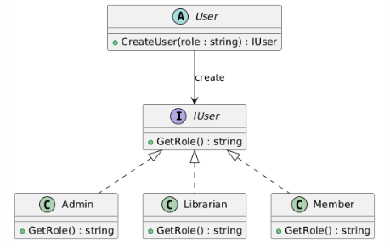

2. BEHAVIORAL PATTERN – STRATEGY PATTERN

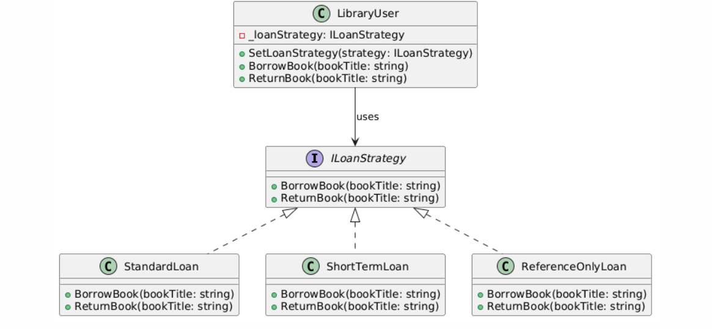

Feature 1: Category Management

Applied Design Patterns

- Repository Pattern
- Service Layer Pattern
- Dependency Injection
- MVC/Razor Pages
1. Domain Model

Models/Category.cs

Represents entity in class diagram.
2. Repository Layer

Interfaces/ICategoryRepository.cs

Maps to repository interface in design.
CategoryRepository.cs

Implements Repository Pattern.
3. Service Layer

Interfaces/ICategoryService.cs

CategoryService.cs

Implements Service Layer Pattern.
4. Dependency Injection Configuration

Program.cs

Demonstrates Dependency Injection.
5. Presentation Layer (Interaction Diagram → Code)

Pages/Categories/Index.cshtml.cs

